Install Python 3.10

*sudo apt update*

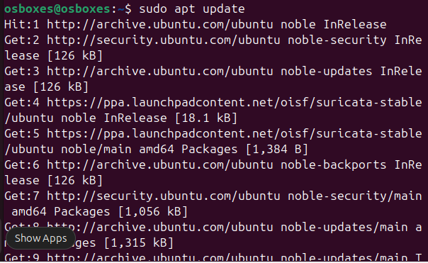

*sudo apt install software-properties-common -y*

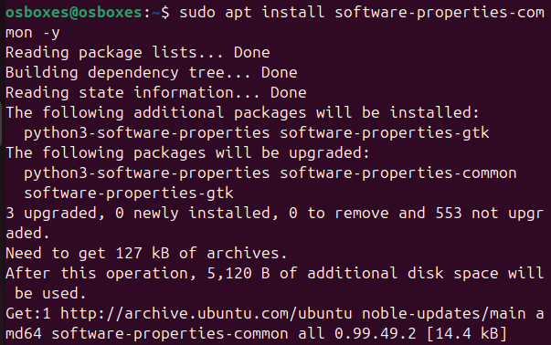

*sudo add-apt-repository ppa:deadsnakes/ppa*

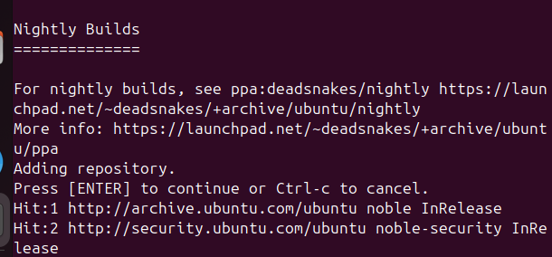

*sudo apt install python3.10 python3.10-venv python3.10-dev -y*

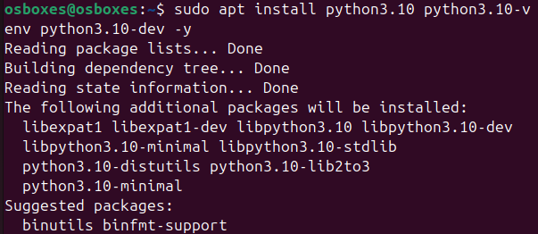

*python3.10 –version*

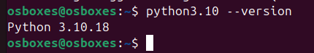

*Sudo apt install git -y*

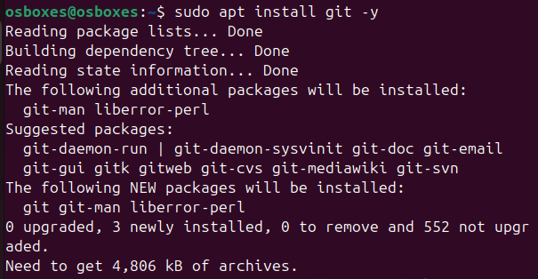

***install Ryu***

*git clone* [*https://github.com/osrg/ryu.git*](https://github.com/osrg/ryu.git)

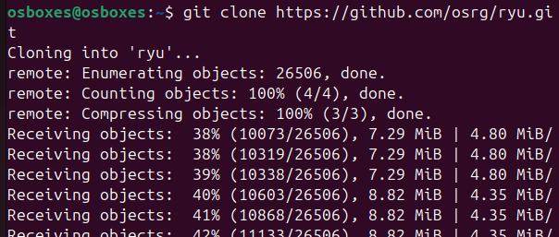

*cd ryu*

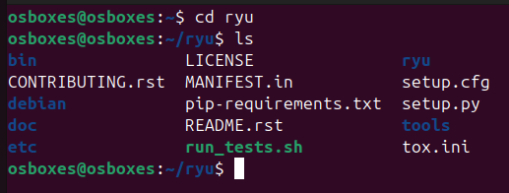

*python3.10 -m venv venv310*

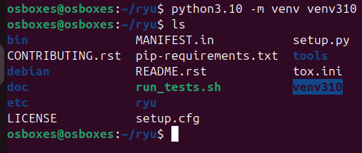

*source venv310/bin/activate*

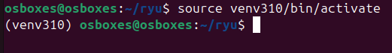

*pip install --upgrade pip setuptools*

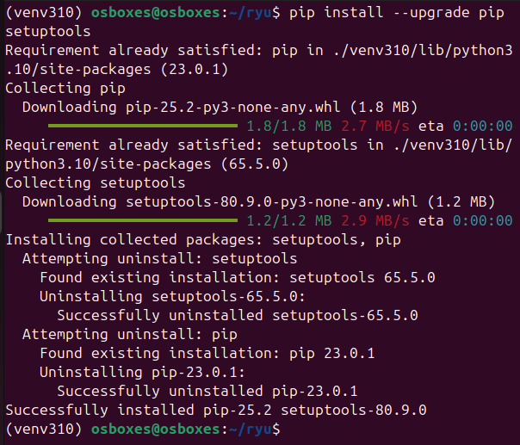

*gedit ryu/hooks.py*

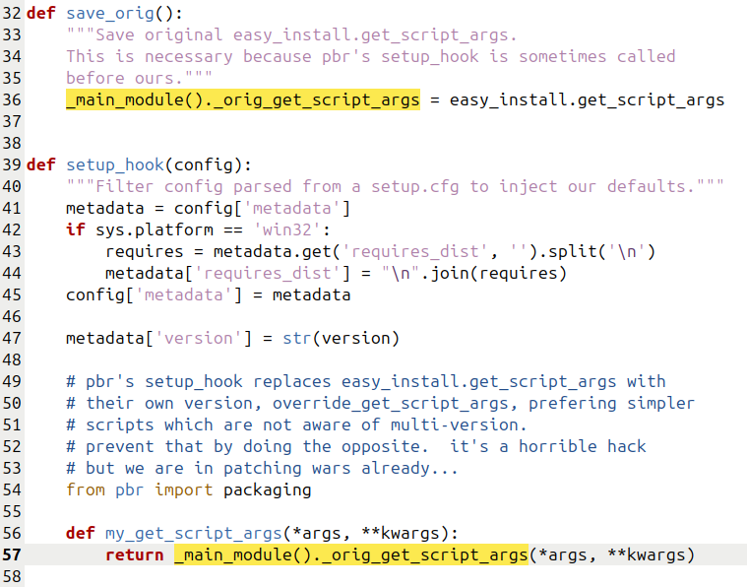

remove the marked items and change

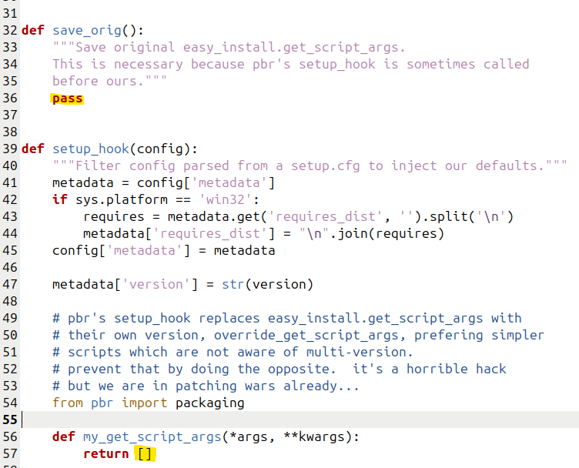

*pip install -e .*

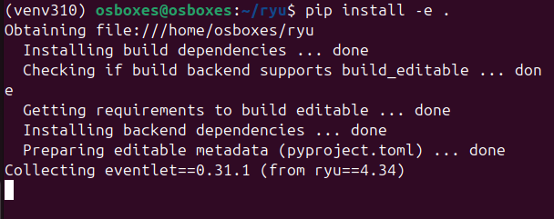

*pip install eventlet==0.33.3*

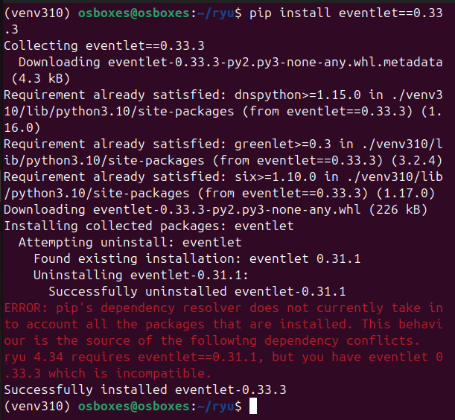

*pip install --upgrade dnspython*

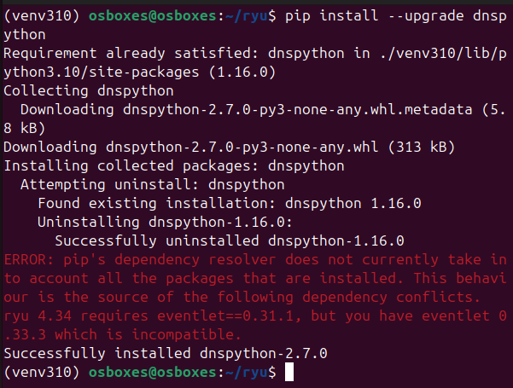

*ryu-manager --version*

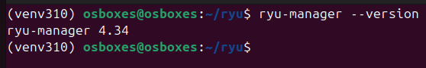

**install Open vSwitch**

*sudo apt-get install openvswitch-switch -y*

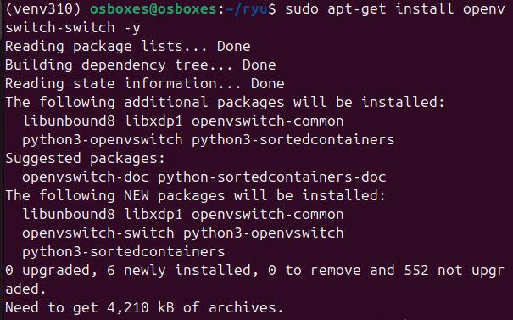

**install Mininet**

*sudo apt-get install mininet -y*

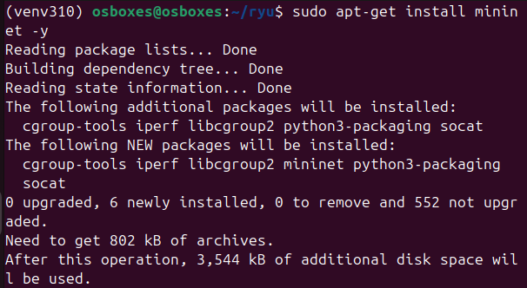

*mn –version*

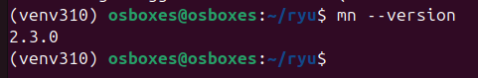

**Running Simple SDN Application (Basic SDN)**

* A Mininet topology (switch + hosts)
* A Ryu controller (simple_switch_13) that acts like a Layer 2 learning switch
* Basic flow table inspection (OpenFlow rules)

Open 3 terminal tabs

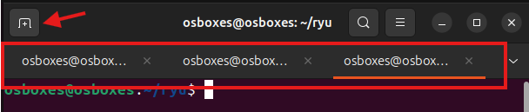

Terminal 1:

*sudo mn --topo=single,3 --controller=remote,ip=127.0.0.1 --mac --switch=ovsk,protocols=OpenFlow13*

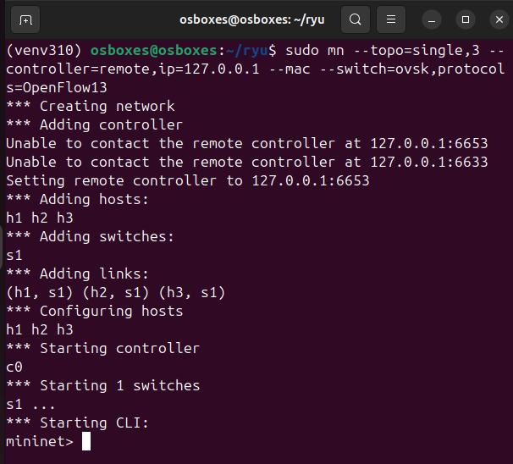

The command in Terminal 1 creates a simple topology in mininet. The topology consists of a single switch and three hosts that are connected to the switch. The topology can be tested by using *pingall* command on the same terminal. At this point, the hosts are unreachable. For making the hosts communicate with each other, there must be some rules which are implemented by the controller.

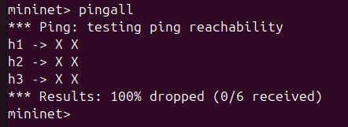

Terminal 2:

*ryu-manager ryu.app.simple_switch_13*

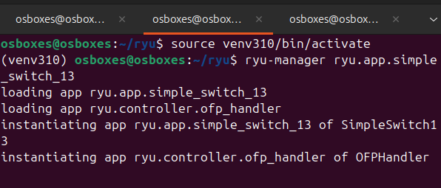

The command in Terminal 2 runs a simple application of switch. The program file for simple_switch_13 locates in /usr/lib/python2.7/ryu/ryu/app/directory. The simple_switch_13 program sets rules and policies in ryu controller, which are necessary for routing packets in a fashion similar to that of L2 Switch of conventional networking. Switch to Terminal 1 and run pingall command again. The hosts will be able to communicate with each other this time. A simple SDN infrastructure has been implemented at this point!

Terminal 3:

*sudo ovs-vsctl show*

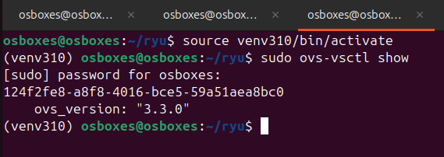

*sudo ovs-ofctl -O OpenFlow13 dump-flows s1*

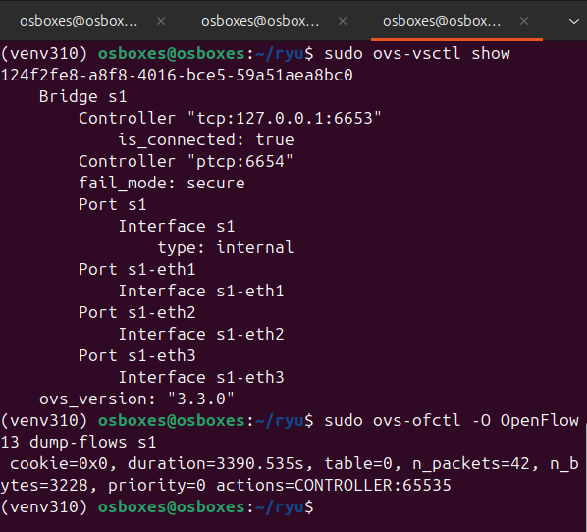

The commands in Terminal 3 show the brief configuration and flow table of Open vSwitch. These commands are used for inspecting the behavior and statistics of SDN switches upon receiving packets from the hosts.

Terminal 1 try ping command

*pingall*

